Comparison

Dataset 0

Self tuning Spectral Clustering (STSC)

For the first dataset the number of clusters that we can observe is:
3

Here the settings are:
Max amount of clusters:
10
K:
7
Similarity Cut:
1

The three clusters that are observed here are correct, when looking to the picture.

When the setting k is changed to 1 then one more cluster can be observed and this is four, so the K value is influencing the amount of clusters
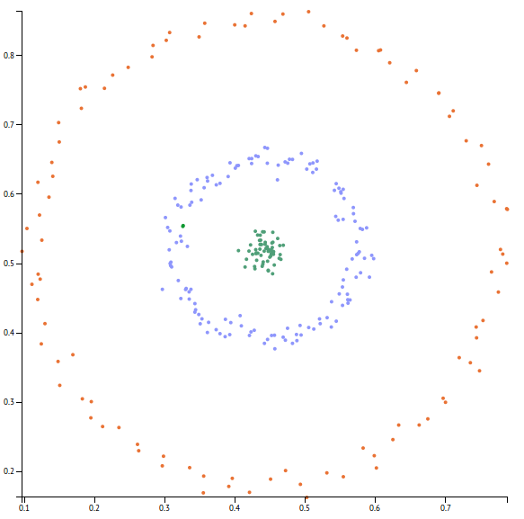

At K is 17 the amount of clusters changes for the first time when k goes up.

At k is 100 and max amount of clusters is 14 the most clusters can be observed for dataset 0 these are 10 clusters.

At a K of 300 the server breaks down and there is no result anymore. Here the 1 CPU runs at 100%, but the result is not produced, optimizing the algorithm for using more CPUs might be a solution here.

Concluding the observations on dataset 0 for the k value it has to be between 2 and 16 and the amount of clusters have to be 10.

Optics Python – Automatic clustering

The python parameter setting for the first run of dataset 0 are:
MinPoints: 7
Epsilon: 0.5
Threshold: 75
This gives a wrong result of two clusters and the most outer ring completely disappeared, see picture below.
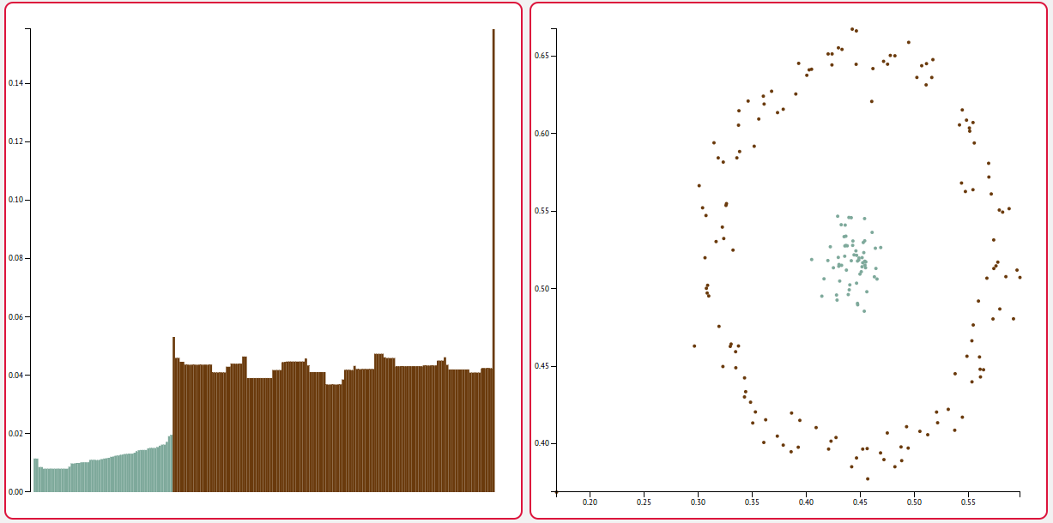

Gradient Clustering ( Optics R)
Tested dataset 0

The standard settings are:
Min points: 15
Epsilon: 10
Angle:120

This gives as a result one cluster. Here the right picture can be seen, but the clusters are not good calculated.
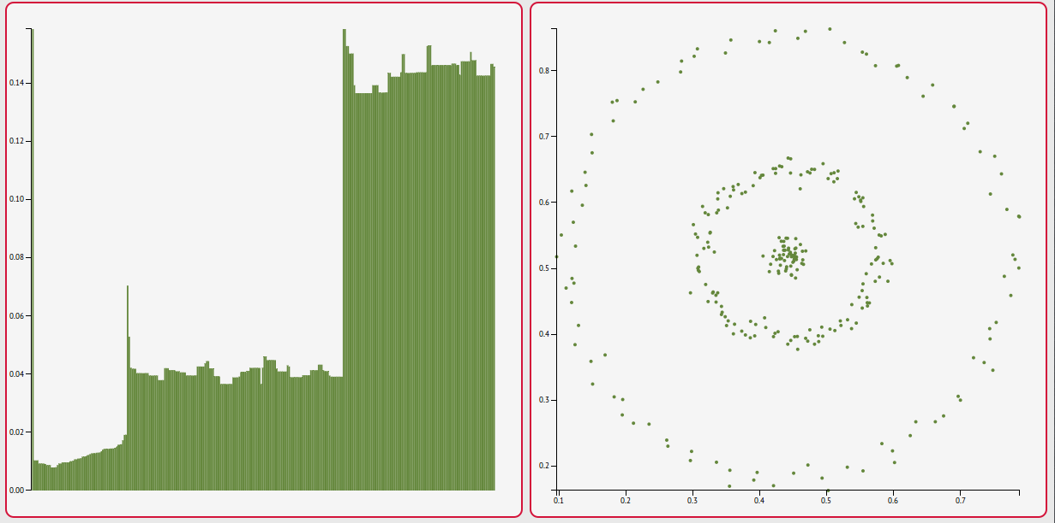

To get the optimal three clusters the only thing we have to do is changing the angle. An optimal angle is achieved when taking 260 degrees.

Here we can see three perfect clusters
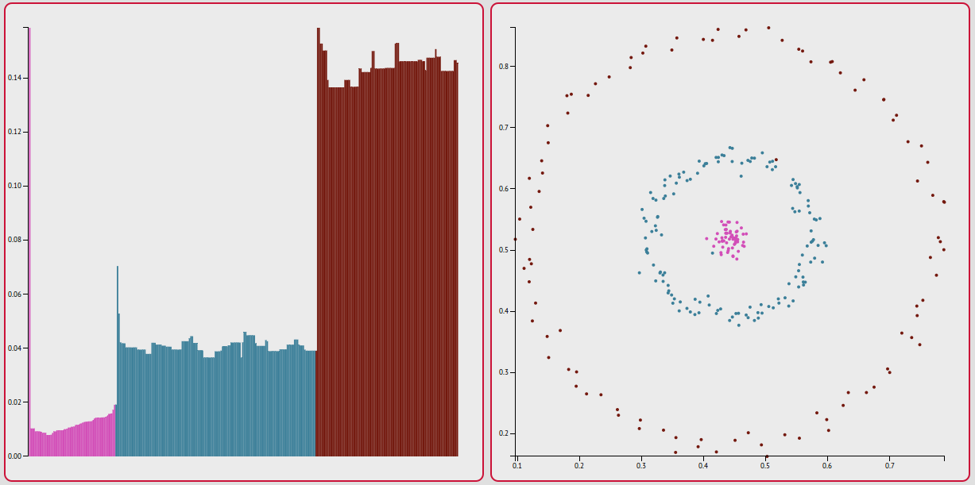

At 270 or 250 only one cluster is found again. This makes that the angle is highly sensitive.
A good result of three clusters can be found between an angle of 254 and 261 degrees.

Dataset 1

STSC
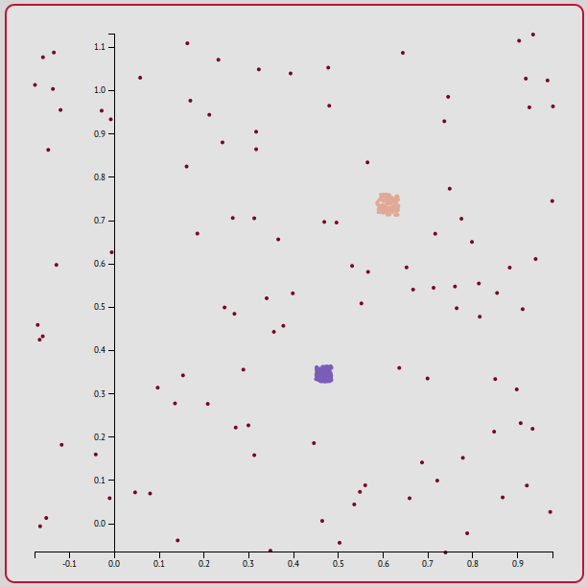
Here the settings are:
Max amount of clusters:
10
K:
7
Similarity Cut:
1

The amount of clusters that can be seen is three and this is optimal. We also see here that the minus points are on the other side of the y-axis.

When a K of 1 is chosen the amount of clusters goes to 8.
Between 2 and 94 the amount of clusters stays three.
From 95 the value changes to 2
From k is 350 the server crashes

Optics python
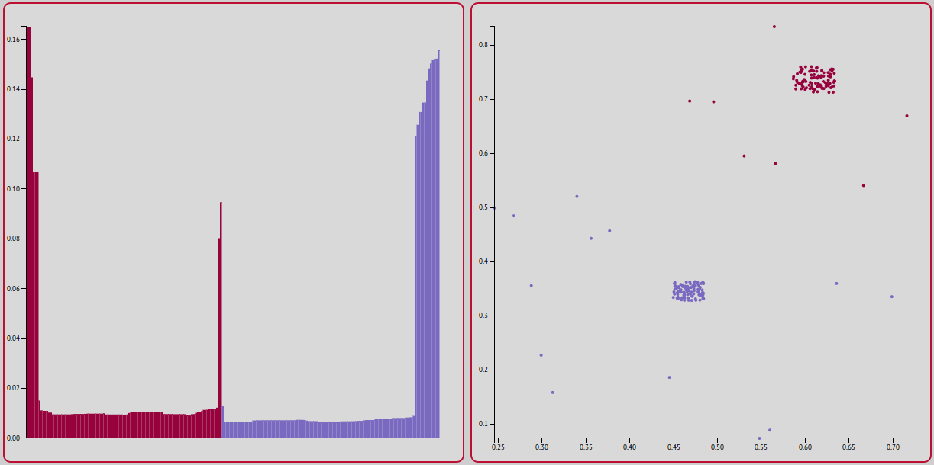
For the standard settings:
MinPoints: 7
Epsilon: 0.5
Threshold: 75

Optics produces two clusters, this is because the outer noise points are connected to the clusters itself, which is wrong

Optics R - Gradient Clustering

The standard settings are:
Min points: 15
Epsilon: 10
Angle:120

Here only one cluster is produced and this is wrong.
The angle 179 produces six clusters.
The angle 330 produces six clusters as well.
After testing it turns out that the Gradient Clustering algorithm doesn’t produce an optimal value with just changing the angle.

Changing the amount of min points to 100 changes the clusters to three, but now there will be a small dense cluster in the bottom big cluster and a big cluster with noise separate.
The six clusters above contain a better result, they also have the separate cluster inside the dense cluster, the surrounding is being recognized as noise.

For the flame dataset

This dataset isn’t tested by STSC
Python works as well worked as well and there is with the standard settings a result with one cluster, this is because one points falls of the cluster because of a wrong epsilon value.
Here immediately this algorithm doesn’t execute it,
The gradient algorithm does execute it and when changing the angle to 180 it produces a optimal result. The angle 179 produces here 7 clusters
181 angle there is 1 cluster

Dataset 2

The STSC algorithm

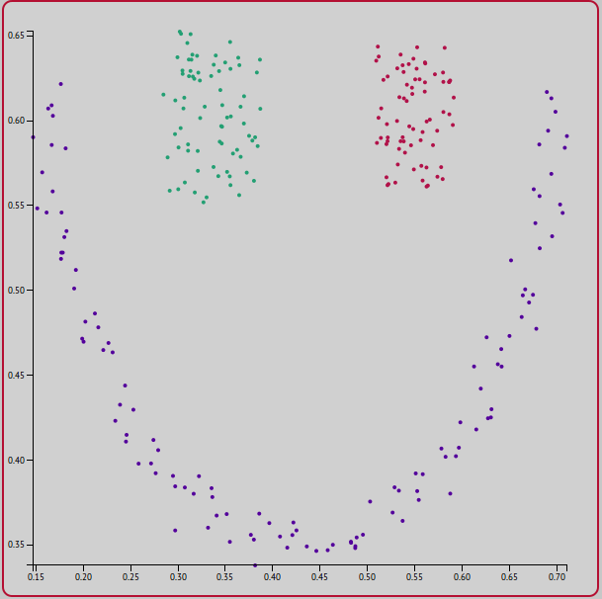

Here the settings are:
Max amount of clusters:
10
K:
7
Similarity Cut:
1

The amount of clusters is here correctly three.
When the k value of 1 is chosen there are 7 clusters
Between 2 and 21 there is a good result with 3 clusters.
From 22 on there are different clusters, 22 has four clusters

